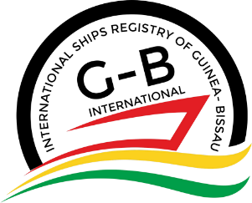
International Ships Registry of Guinea-Bissau

G-B International

APPLICATION FOR RADIO ACCOUNTING AUTHORITY APPROVAL

Part A – MAIN INFORMATION
1) Name of the Company:
2) Company Address:
3) Company Telephone/ Fax:
4) Company Email/ Website:
5) Name of Company’s Authorized Person:
Part B – REQUIRED DOCUMENTATION TO BE SENT WITH THE APPLICATION
6) Copy of Certificate of Incorporation including Director’s name, Resident Agent, Address and Date of Incorporation: |  |  |  | ☐Yes ☐No
7) Acceptance Letter from other Flag Administrations: |  |  |  | ☐Yes ☐No
8) Copy of Company’s Authorized Person Passport: |  |  |  | ☐Yes ☐No
Part C – AGREEMENT
9) The RAA shall follow Guidance, Rights and Obligations, as indicated in G-B I.S.R. Marine Circular 10/ 2022 in its updated form
Part D -SIGNATURE OF APPLICANT
10) Name:
11)Signature: |  |  | 12)Date:
DATE RECEIVED | DATE ASSESSED | RESULT – AUTHORISED/REJECTED | NOTES
(name-signature) |  | (name-signature)
Approved by the  Deputy General Ships Registrar |  | Approved by the  General Ships Registrar

